Troubleshooting and Quality Control of Devices and Infection

Name
Institution of Affiliation
Professor
Date

Troubleshooting and Quality Control of Devices, and Infection Control
1- Whistling sound in a bubble humidifier? How would you troubleshoot it? 2- How is the proper function of a humidifier?
Humidification
Bubble humidifiers are devices that are commonly used in clinical practice when there is excess oxygen delivery. These single-use devices are used to humidify supplemental oxygen. This device is disposable. When using the device, a whistling sound may be heard. Sometimes, this sound may come by itself. This shows that the rate of flow of oxygen is exceeding the standard limit. This may also show that the tube is obliterated. There is a need to troubleshoot the device (Shetti et al., 2014). The pop-off valve provides a warning that the flow rates are high and release excess pressure due to high flow rates. The humidifier functions appropriately when there is no whistling, and the bubbling is present. The absence of bubbling may signify a malfunctioning humidifier due to inadequate pressure and flow, of obstruction. The diagram below (figure1) shows a bubble humidifier.
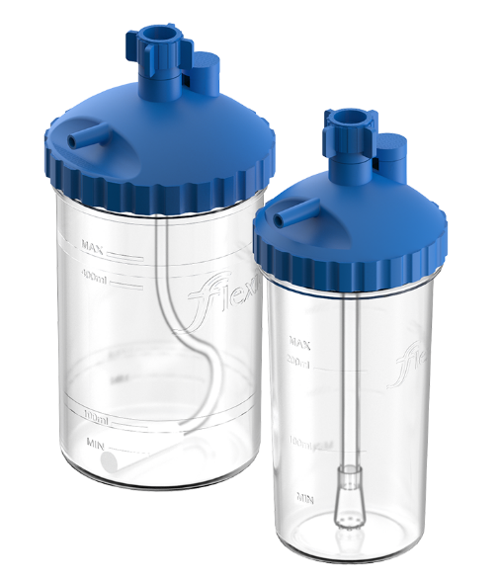
Figure 1: An image of bubble humidifier by Flexicare. Adapted from https://www.flexicare.com/product/bubble-humidifier/
When providing a handheld nebulizer, what sound indicates that the solution has been nebulized? 4- What causes an LVN not to mist enough? Provide three possible causes. 5 - What can cause the FiO2 to change during LVN therapy? How can it be fixed?
Nebulization
Nebulizers mists medications for proper aerosol or inhalation therapy. When using handheld nebulizers, the click sound signifies the release of medications has been triggered. Another click sound after administering medications will indicate the inhaler is closed and the medication delivery is complete. Low-Volume jet Nebulizers (LVN) are most indicated for children. Various issues can cause these nebulizers not to mist enough (Gardenhire et al., 2017). When the tube is kinked or bent sharply, the LVN would not mist enough (Moody & Ari, 2020). The capillary tube can sometimes become clogged. The clogging causes an obliteration that causes the LVN not mist appropriately. Sometimes the flow being supplied is inadequate. The medications are insufficient to enable the LVN to mist enough. When water enters and collects in the tubing, minimal amounts of air are entrained. The patient’s respiratory rate and the speed or pressure of flow would also increase the Fraction of Inspired Oxygen (FiO₂). A therapist should, therefore, adjust the oxygen supply and regulate the switch.
6 - During Incentive Spirometry, what common troubleshooting problems you may find? Related to the formula to calculate expected volume, patient coordination, avoidance of gastric distention
Incentive spirometry aids the lungs in the recovery process after a pulmonary illness or surgery. A therapist may encounter problems when administering incentive spirometry to the patient. There may be difficulties coordinating with the patient ton when to administer spirometry or when to call to seek urgent attention when using spirometry.
1. 2) low-flow, high flow, and variable oxygen system. What are they and the benefits of them? How do you decide what oxygen device to use? Why is supplemental oxygen necessary?
Oxygen therapy is administered at varying rates and volumes. There are different devices used to determine flow rates and volumes. Different devices deliver oxygen at different rates. The choice of the device is determined by the patient's age, the severity of the illness. The saturation of oxygen indicates the oxygen deficit. Low flow systems use face masks and nasal prongs. They are essential in pediatric oxygen therapy. High flow systems include ventilators and continuous positive airway pressure (CPAP) drivers (The Royal Children's Hospital Melbourne, 2020). The treatment goals and oxygen requirements and patient’s age determine the type of systems used to deliver oxygen. However, sometimes, a patient with a high oxygen saturation may not necessarily need low flow oxygen therapy a supplemental oxygen therapy may be necessary (Reminiac et al., 2018). The progress determines the need to switch between the oxygen flow systems.
Two Paragraphs about Vital Signs and Patient Bedside Assessment
The progress of the patient is assessed through vital signs and bedside examination. The vital signs that can be assessed in a patient at bedside include blood pressure, pulse, respiratory rate, temperature, oxygen saturation level and heart rate. The vital signs provide information regarding the general condition of the patient and what should be prioritized when attending to the patient. For example, if the patient has a weak pulse, it means the cardiovascular system is failing and attention should be directed at stabilizing the cardiovascular system and investing on what might be causing the failure.
Bedside assessment should ensure the airway, breathing, and circulation is checked as frequently to ascertain the patient's progress. Bedside assessment refers to the general assessment of the patient condition. These include assessment of the level of consciousness, any discomfort and pain and any deformity that the patient may have. Through physical examination, the general examination will be able to pick anemia in form of pallor, desaturation in form of cyanosis and even breathing problems. Symptoms such as cyanosis and confusion indicate hypoxemia that requires oxygen therapy.

References
Gardenhire, D., Burnett, D., Strickland, S., & Myers, T. (2017). A Guide To Aerosol Delivery Devices for Respiratory Therapists (4th ed., p. http://c.aarc.org/go/adu). American Association for Respiratory Care.
Moody, G., & Ari, A. (2020). Quantifying continuous nebulization via high flow nasal cannula and large volume nebulizer in a pediatric model. Pediatric Pulmonology. https://doi.org/10.1002/ppul.24967
Shetti, A., Karigar, S., & Kunakeri, S. (2014). An unexpected error in oxygen humidifier. Saudi Journal Of Anaesthesia, 8(4), 567. https://doi.org/10.4103/1658-354x.140911
The Royal Children's Hospital Melbourne. (2020). Clinical Guidelines (Nursing): Oxygen delivery. Rch.org.au. Retrieved 16 October 2020, from https://www.rch.org.au/rchcpg/hospital_clinical_guideline_index/Oxygen_delivery/.

